State Machine Diagram

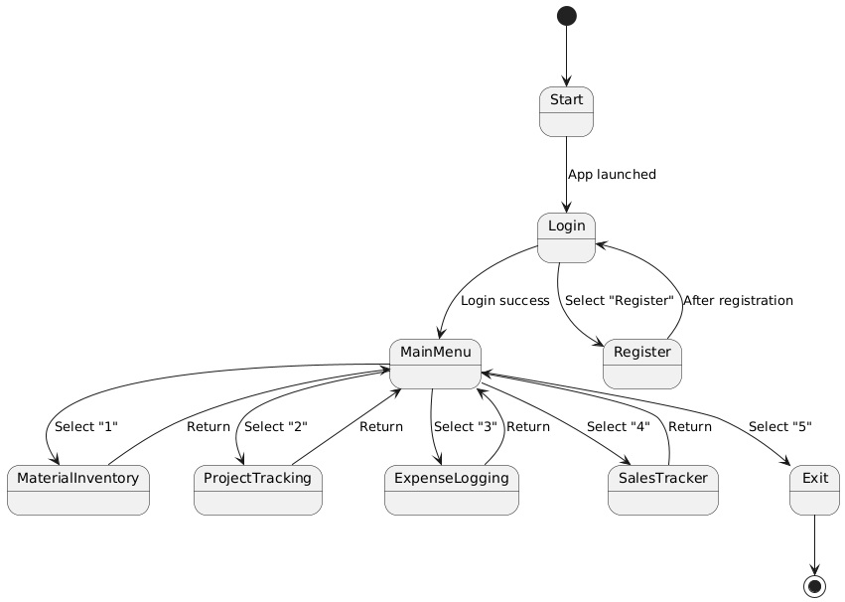

@startuml

[\*] --> Start

Start --> Login : App launched

Login --> MainMenu : Login success

Login --> Register : Select "Register"

Register --> Login : After registration

MainMenu --> MaterialInventory : Select "1"

MainMenu --> ProjectTracking : Select "2"

MainMenu --> ExpenseLogging : Select "3"

MainMenu --> SalesTracker : Select "4"

MainMenu --> Exit : Select "5"

MaterialInventory --> MainMenu : Return

ProjectTracking --> MainMenu : Return

ExpenseLogging --> MainMenu : Return

SalesTracker --> MainMenu : Return

Exit --> [\*]

@enduml